REPORT FROM WARWICKSHIRE COUNTY COUNCILLOR
JAMES CROCKER

- On a personal note, I have been elected Deputy Leader of our group at Warwickshire County Council, which we expect to be formally ratified at the AGM on 14th May. One of the main reasons for putting myself forward was to ensure that the south is represented, with a strong voice at cabinet.
- Missing speed hump had been delayed by an objection, but now resolved and in the process of being implemented. No timescale provided at present, but Minor Works team are well aware.
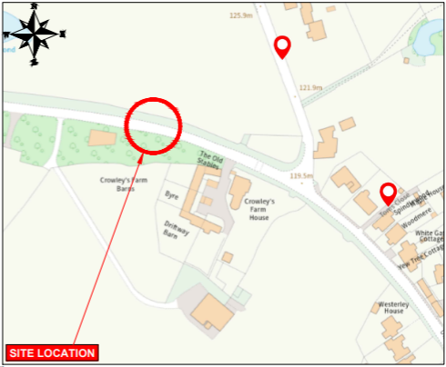
- Traffic surveys around Ullenhall, Wootton Wawen and Henley are being undertaken by WCC:
The purpose of the recent ATC surveys is solely to gather traffic volume data, which will be used to support updates to our transport models. These models are an essential evidence base for future planning work, particularly in preparation for the release of the Local Plan for the area. They are not being used to monitor vehicle speeds or assess compliance with the current speed limit.
The data can be purchased via this link: https://www.warwickshire.gov.uk/traffic-surveys/request-traffic-survey-data after the survey period. However, we don't recommend using the data for speed because the survey wasn't planned to gather speed data.
As such if the Parish Councils are interested in this data, they should contact:
trafficsurveys@warwickshire.gov.uk

NEWS FROM SHIRE HALL
Raising of threat level to severe – statement from Deputy Chief Constable Ben Smith
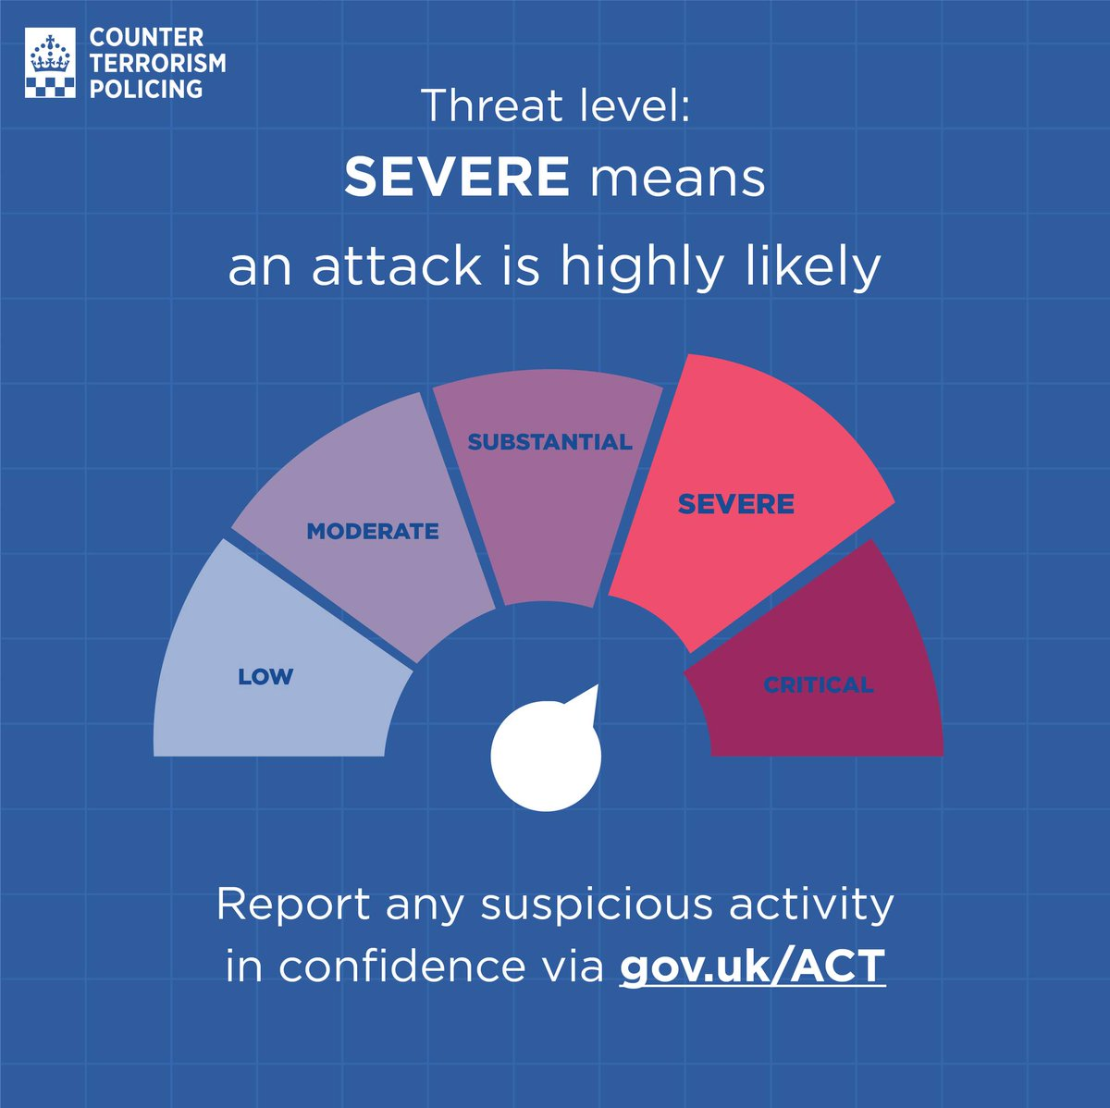
Deputy Chief Constable, Ben Smith said: “You will have seen in the news that the UK terrorism threat level has been increased from substantial to severe – meaning an attack in the UK is highly likely.
“This change comes following a series of recent incidents targeting Jewish communities in London, and our thoughts very much remain with all those impacted by these horrific attacks.
“The raise in threat level will no doubt be a cause of significant concern. I therefore wanted to give some information and reassurance about what this means for us all here in Warwickshire.
“The change in the threat status is in response to those recent events and is a precautionary measure, not based on any specific threat.
“But we do all need to be vigilant. Warwickshire Police will continue to be visible in our communities, and will be working with partner agencies, local businesses, and faith groups to share information and advice on security, what to be on the look-out for and how to report any concerns.
“Communities defeat terrorism, and we are asking you, the public to remain vigilant and report any suspicious activity to the police.
“Your support is essential, and communities across the country continue to show they stand together against anyone who tries to divide them.”
If you do see anything that doesn’t feel right, please report it via www.gov.uk/ACT. In an emergency, always call 999.
More information about what to do if you are concerned about the behaviour of someone close to you can be found on the https://actearly.uk website, including how to spot the signs of radicalisation and where to go for support.

Warwickshire tops bus service satisfaction survey

Warwickshire County Council is very pleased with the results of the 2025-26 ‘Your Bus Journey’ survey, conducted by independent watchdog Transport Focus, which revealed a 93% overall passenger satisfaction rating.

Read more: https://www.warwickshire.gov.uk/news/article/7517/warwickshire-bus-services-top-national-satisfaction-charts-in-latest-survey
Pothole Allegations Made by Rachel Taylor MP Dismissed By George Finch, WCC Leader
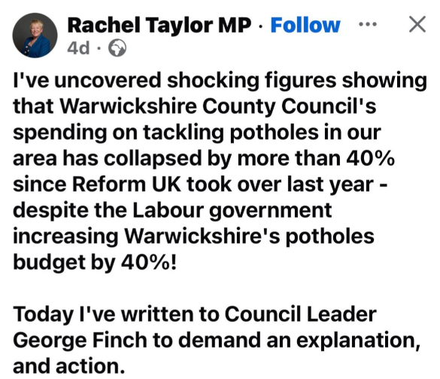
In a written response from George Finch, Rachel Taylor MP misused selective FOI data on potholes and ignored key context. Capital spending on carriageways and footways has risen 45%, from £16.9m to £23.9m, with extra focus on pothole repair and prevention. The council states 11,486 potholes have been filled so far this year and that more of the network is now in good condition. He explains funding is still limited, work is prioritised by data not “wish-lists”, new methods and the JCB Pothole Pro are being used, and invites discussion instead of public misrepresentation.

Cost of living website: I need support now

If you are a Warwickshire resident with no other access to funds to pay for food or energy bills, you may be eligible for support through the Crisis and Resilience Fund (CRF).

https://www.warwickshire.gov.uk/crisisresiliencefund

Victim of Crime survey
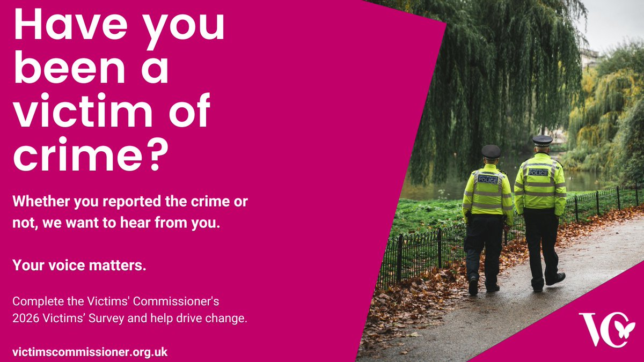
Have you been a victim of crime? Make your voice heard. Complete this survey to improve the justice system for future victims.

Victim Survey for England and Wales 2026 — TONIC

MY RESPONSIBILTIES AS WARWICKSHIRE COUNTY COUNCILLOR
- Deputy Leader of Warwickshire County Council, from 14th May 2026.
- Within Warwickshire County Council, other parishes in the Arden division include Henley-in-Arden (and Beaudesert JPC), Wootton Wawen, Claverdon, Langley, Tanworth-in-Arden (including Earlswood), Wolverton and Preston Bagot.
- Serving on both the Warwickshire Fire & Rescue Local Pension Board of the Firefighters’ Pension Scheme and the Warwickshire Pension Fund Local Pension Board.
- Member of the cross-party working group for the Bus Service Improvement Plan. I have recently received a number of requests from residents asking for service extensions to key areas such as Warwick Hospital. If you have any views or suggestions regarding local bus services, please do not hesitate to get in touch.
- Representative on the Member Oversight Group, a cross-party body focused on WCC’s investments, trading companies and including the Warwickshire Investment Fund.
- Member of the Audit & Standards Committee, concerned with ensuring that WCC has robust systems of internal control and making sure that both councillors and officers follow high standards in the way they conduct the business of the council.

Separately, also Chair of the Reform UK branch for Stratford-on-Avon.

Getting in Touch
For any issues or ideas that would benefit Ullenhall, as your representative, I am always available to listen and support local priorities at Warwickshire County Council.

James Crocker
County Councillor for Arden
Warwickshire County Council Email: jamescrocker@warwickshire.gov.uk

Mobile: 07353 157962

